https://www.jdoodle.com/embed/v0/61E0
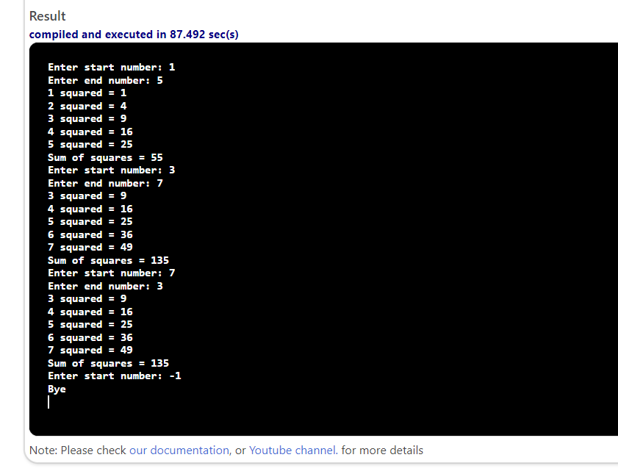

#include <iostream>
using namespace std;
int main()
{
int startNum, endNum, n, nSquared, sos;
cout << "Enter start number: ";
cin >> startNum;

while (startNum >= 0) {
cout << "Enter end number: ";
cin >> endNum;
if (startNum > endNum)
{
swap(startNum, endNum);
}
sos = 0;
for (n = startNum; n <= endNum; n++) {
nSquared = n * n;
cout << n << " squared = " << nSquared << endl;
sos += nSquared;
}
cout << "Sum of squares = " << sos << endl;
cout << "Enter start number: ";
cin >> startNum;
}
cout << "Bye" << endl;
return 0;
}

